Due date: Week 06: Wednesday, October 12, 2016

Purpose:

Install VIM editor , create Linux clone, create and remove MBR partitions from a Linux Virtual Hard Disk

Procedure:

Important: - In this lab we will be using the Linux **clone** in case you really mess things up.

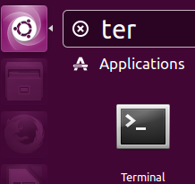

Note: Make sure you answer the questions and have a snapshots

of your work.

**Install Vim editor in your Linux VM**

Dash

1- log in to your Linux VM and go to the **Dash** and type **Terminal**

2-Click on the **Terminal** tab, you will see the command line



In the **Terminal** screen type: **sudo apt-get install vim** and press **enter** then provide the **password**. (sudo is the administrator account)

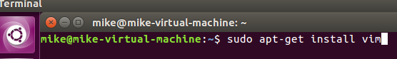

Linux will install vim editor into your VM.

Note: make sure you have access to the internet from your VM)

**Create a clone of your Linux os**

1- first shut down your VM. Go to the command line and type:

sudo shutdown -h now press enter (all lower case)

2-In your VM screen select **VM** => Manage => **Clone**

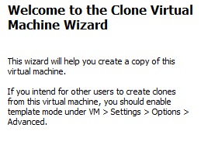

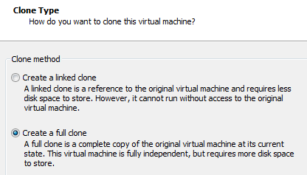

3-After going through the default setting the **clone type** screen

comes up, select **Create a full clone** click **Next**

4- Then **finish**

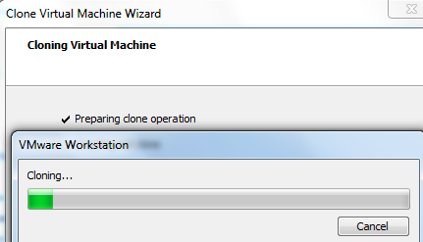

5- cloning process take a few minutes

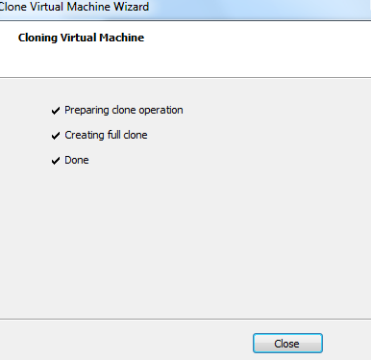

6-click **Close**

**Adding a new virtual hard drive to an existing VM**

Select your **Linux clone** from your VM library and add a new virtual hard disk. Double click on your **VM hard drive**, this brings up the **Virtual Machine Settings** as shown in Figure 1 below.

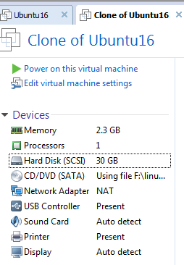

Figure 1. Double Click on the Hard Disk (SCSI)

Select the **Hard Disk** click on the **Add** button, see Figure 2, located on the bottom of the screen on the left hand side.

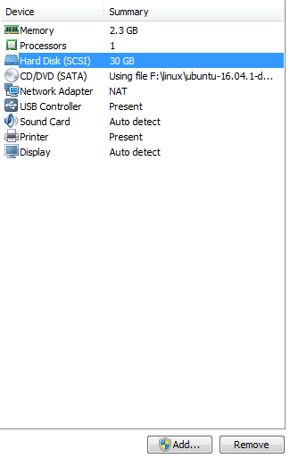



Figure 2. Add Button

This brings up the **Add Hardware** Wizard, see Figure 3. Select the Hard **Disk** and click the **Next** button.

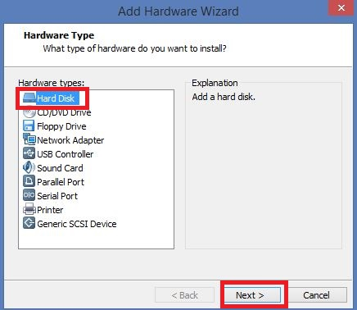

Figure 3. Add Hardware Wizard.

Accept the default options from the **Select a Disk Type** Menu and click the Next button.

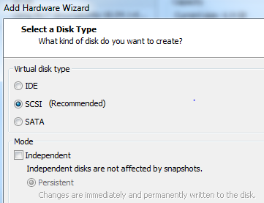

Select the **Create** a new virtual disk radio button and click the **Next** button.

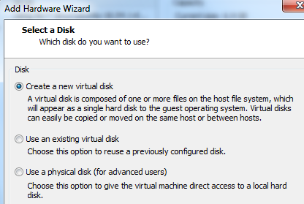

click **Next**

Select a **Maxim** disk size of **4 GB** and select the **Store virtual disk as a single file**, as shown in Figure 5 below.

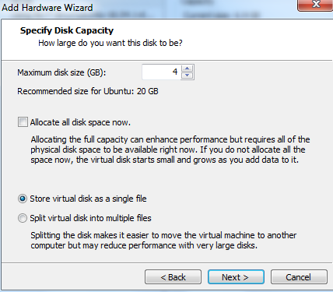

Figure 5.Hard Disk Size.

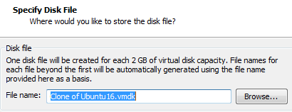

Click the **Next** Button and accept the

default name for the disk file. Click **Finish.**

You will now be taken to the **Virtual Machine Settings** menu and you should see a **4 GB** drive displayed. Click the **OK** button.

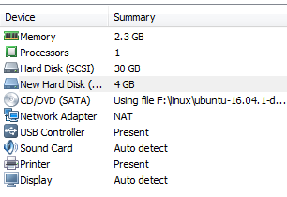

Power on the **Virtual Machine** and log on to your Linux VM. (clone Ubuntu)

***Exercise #1: Viewing existing partitions***

Go to your clone VM and then **Terminal**

Switch to root user with the command: **sudo -s – root** press enter

When prompted enter your root password and hit enter, remember nothing will show on the screen when you type your password.

**Note**: the prompt user has been changed from ~$ to ~# (sudo prompt)

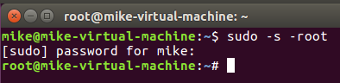

To manage partitions, we will be using **fdisk**

The syntax of the **fdisk** command is: **fdisk */dev/device_name***

* Type **fdisk /dev/sda (be carful there is a space between fdisk and /dev)**
* Within the **fdisk** utility type **m** for a list of menu options at the "Command (**m** for help):" prompt

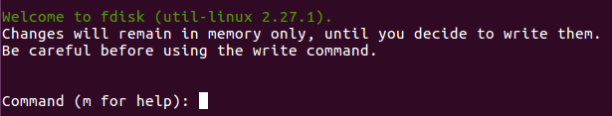

**Questions**

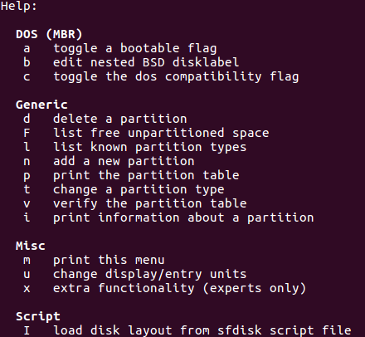

* Record the (one-character) fdisk command to:
  + display/list all partitions: __p__
  + create a new partition:  _n__
  + delete a partition: __d__
  + list partition types: __l__
  + change a partition's system identification: __t__
  + save changes made to the partition table: _w__
  + exit **fdisk** without saving: ___
* Select the option that lists the partition types and record the **system id** of the following types:

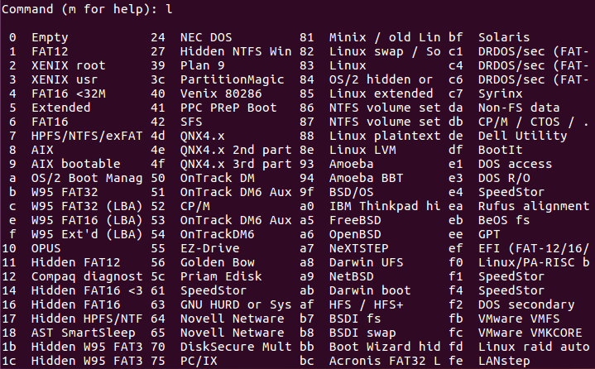

* + "Linux": __83___
  + "Linux swap": __82___

***p***

***Exercise #2: Creating partitions***

Start a **Terminal** and switch to root user with the command: **sudo -s – root**

When prompted enter your root password and hit enter, remember nothing will show on the screen when you type your password.

1. Switch to the new hard drive by typing: **fdisk /dev/sdb**

A warning may appear – ignore it.

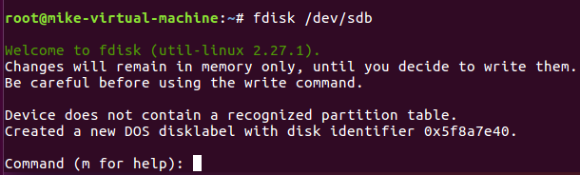

1. Create a new primary partition by selecting **n**, then select **p** for primary partition and select the number one,**1,** for the partition number. Accept the default for the first sector by pressing the **Enter** key. The size of the primary partition is 500MB**, so** enter **+500M** and press enter

Note: make sure you follow the down figure exactly

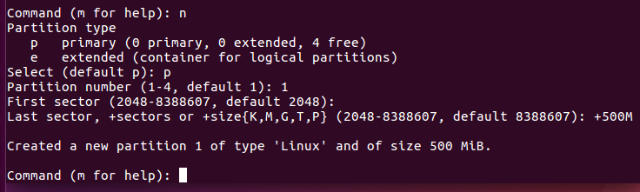

enter here

hereeree

1. Press the **p** key to display the primary partition you just created in the partition table.

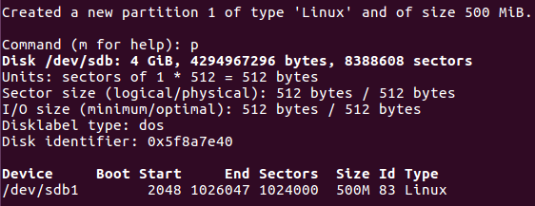

1. Create another **primary** partition by selecting the **n** key, then select **p** for primary partition and select the number **2** for the partition number. Accept the default for the first sector by pressing the **Enter** key. The size of the second primary partition is 200MB**,** so enter **+200M** and press the **enter key.**
2. Press the **p** key to display the two primary partitions you just created in the partition table.

Create an extended partition to host three logical drives - keep in mind that you must make it large enough to encapsulate the logical drive described below. HINT: There will be problems if you try to make it exactly **1000MB.** So you will need to experiment; try entering **1005MB** instead:

1. To create an extended partition press the **n** key, then select the **e** key for an extended partition. Select the number **3** for the partition number. Accept the default for the first sector by pressing the **Enter** key. The size of the extended primary partition should be 1000MB but your will get an error**,** soenter+**1005M** and press the **enter key.**
2. Press the **p** key to display the two primary partitions and the extended partition you just created in the partition table.
3. To create a logical drive in the extended partition press the **n** key, then select the **l** key for a logical drive. A logical drive is created and is numbered 5. Accept the default for the first sector by pressing the **Enter** key. The size of the logical drive should be 500MB,soenter **+500M** and press the **enter key.**
4. Press the **p** key to display the two primary partitions, the extended partition and the logical drive you just created.
5. To create another logical drive in the extended partition press the **n** key, then select the **l** key for a logical drive. A logical drive is created and is numbered 6. Accept the default for the first sector by pressing the **Enter** key. The size of the logical drive should be 300MB,soenter **+300M** and press the **enter key.**
6. Press the **p** key to display the two primary partitions, the extended partition and the two logical drive you just created.
7. To create another logical drive in the extended partition press the **n** key, then select the **l** key for a logical drive. A logical drive is created and is numbered 7. Accept the default for the first sector by pressing the **Enter** key. The size of the logical drive should be 200MB so enter **+200M** and press the **enter key. You may get an error here – value out of range depending on the size you made your extended partition. If you get an error make your partition size smaller say 197M.**

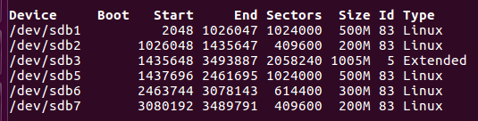

1. Press the **p** key to display the two primary partitions, the extended partition and the three logical drive you just created. Record the output by taking a screenshot using the Windows **Snipping tool** (snapshot) and pasting it here:

## **Changing Partition Types**

1. You will notice all the partitions are of type Linux. We want to change the **/dev/sdb7 Linux** partition to a **Linux Swap** partition. To change the partition to Linux Swap Partition press the **t** key then enter**7** to select the 7th partition. When prompted for the Hex code, enter **82** and hit the enter key. **82** is the hex code for a **Linux Swap partition**. If you want to see the other codes available to you enter the **l** key when prompted for the hex code.
2. Press the **p** key to display the two primary partitions, the extended partition and the three logical drive you just created. Record the output by taking a screenshot using the Windows Snipping tool and pasting it here:

## **Questions to test your understanding**

|  |  |
| --- | --- |
| List all the primary partitions on the new 4GB drive | **/dev/sdb1**  **/dev/sdb2** |
| Name the extended partition if one exists on the new 4 GB drive | **/dev/sdb3** |
| List all logical drives if they exist on the new 4GB drive | **/dev/sdb5**  **/dev/sdb6**  **/dev/sdb7** |
| Can you create additional primary partitions on the new 4GB drive? | No |
| Can you create additional logical drives on the new 4GB drive? | No |

## 

## **Deleting a Partition**

1. We will be deleting the **300MB** partition, To delete a partition, press the **d** key, you will be prompted for the partition number that you want to delete, press the **6** key and hit the enter key as that is the partition that we wish to delete.
2. Press the **p** key to display partition table. Record the output by taking a screenshot using the WindowsSnipping tool and pasting it here:
3. What do you notice in terms of the partition numbering?
4. **Save y**our work to the **hard disk** by pressing the **w** key, this writes the partition table information to the hard disk
5. Press the **q** key to quit fdisk program
6. You are now ready to call the lab instructor over to sign off on your lab.
7. type **exit** to get out of the **user root**.